Gabriel Y. Diaz Morro 802185131

**Assignment #4: Median Filter Report**

The Client is asked for a path which is sent to the servers. The MedianFilters object applies filterRange to the selected image, which creates a pixelWindow array that stores all the pixels values in the image. Then all the rgb values are stored in another array, which later are sorted and then the median is taken for each color and is applied to the pixels in that row and column. The ParallelServer and SimpleServer classes saves the processed images using the according algorithm. After running the program 4 times, on average the parallel algorithm took around 0.15856 seconds and the simple algorithm took on average 0.586309 seconds. In conclusion, the parallel algorithm was faster because it did not completely remove the noise from the image, while the simple median filter was slower but produced a clearer image.

Parallel Median Filter, elapsed time: 0.1678608s

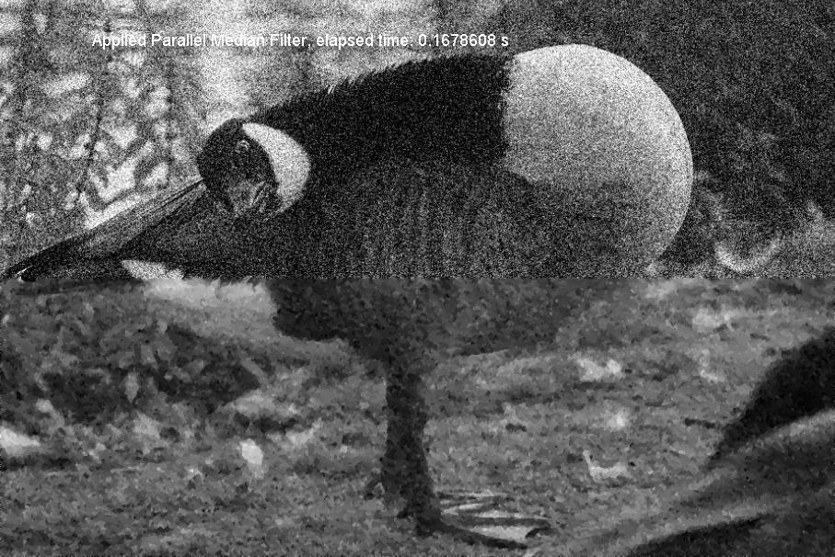

Simple Median Filter, elapsed time: 0.5456981s

